**Start-up Week Meeting Items**

The following are the items for discussion & planning:

* Project Objective & Scope
* Schedule & Milestones

|  |  |  |
| --- | --- | --- |
| **Date** | **Activities** | **Milestones** |
| **Start-up Week** (April, 6-12) | Team Formation & Project Planning | Project Plan & Flow Chart |
| **1st Week** (April, 13-19) | Research, Data Cleaning/Calculation, & Load to Database | Data Cleaning Files & Database |
| **2nd Week** (April, 20-26) | Data Analysis & Web Design | Website & Dynamic Charts & Map Files |
| **3nd Week** (April 27 - May 3) | Data Analysis & Prediction with Machine Learning | Web Files with Demo |
| **4nd Week** (May, 4-9) | Presentation & Practice | Project Plan Result & PP Slide |

* Flow Chart

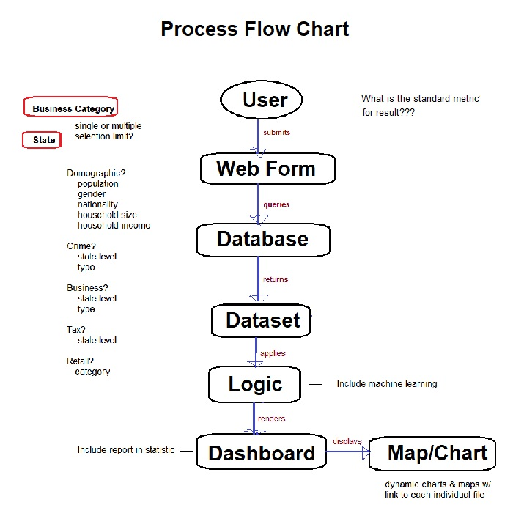

* Dataset & code run-through
* Automation Code & Database Design
* Tasks Assignment